
Japan Information and Cultural Center
Embassy of Japan
2627 Roxas Boulevard, Pasay City
http://www.ph.emb-japan.go.jp
Tel. No. (02) 551-5710 loc 2311 Fax No. (02) 551-5784

HELLO! JAPAN REQUEST FORM

Hello! Japan Program is designed to introduce students to Japan and Japanese Culture. Each presentation is about one hour and a half and is conducted only during the weekdays (Monday-Friday). It includes a brief general introduction to Japan followed by interactive activities based upon a specific topic requested by the school or organization. These services are FREE of charge.

To schedule a session at your school or at the Embassy of Japan, please have the classroom teacher or the coordinator who is overseeing the session fill out the following information. We will try to accommodate as many requests as possible. However, please note that because of the limited number of staff, we may not be able to accommodate all requests. To facilitate communication, we ask you to provide us with as much contact information as possible, including your email address, telephone/mobile phone and fax numbers.

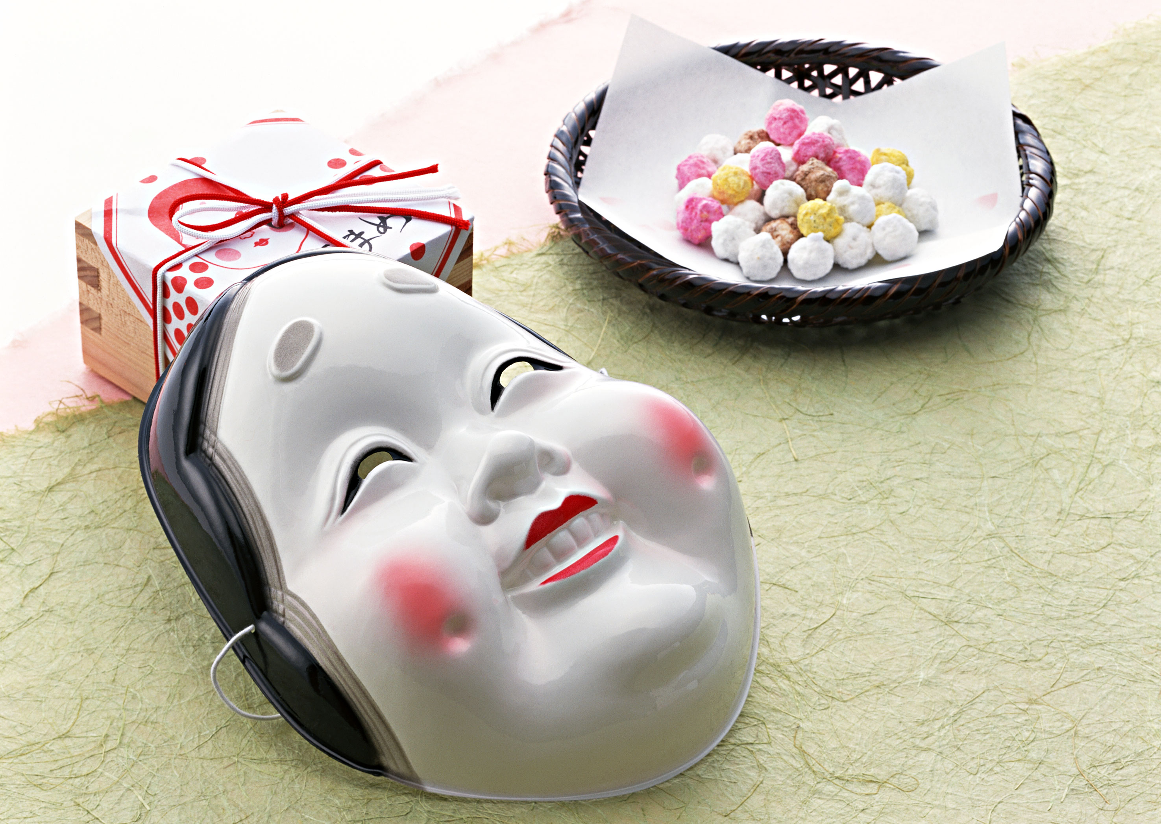
Name of School/Organization: ___________________________________
School Address: ______________________________________________
Name of Coordinator: __________________________________________
Position at School: ____________________________________________
School Phone No: ( ) _________________ Fax: ( ) ______________
Other Contact Number ( ) ____________________________________
Email Address: _______________________________________________

- School and Class Information
  - Grade or Year Level: _________________________________
  - Type: Public or Private (Please encircle one.)
  - Date and Time you would like to schedule Hello! Japan. (Please list three options.)
Preferred Choice: Date: __________ Time: _____________
2nd Choice: Date: __________ Time: ______________
3rd Choice: Date: __________ Time: _______________
  - Class or Group Size (Please limit group size to 45 or less) _________
  - Students’ background knowledge regarding Japan (Information covered, materials used):_______________________________________________
For School Visits: (METRO MANILA ONLY)
A/V Equipment Available for Use (Please check all that apply.)

TV with VCR VCD or DVD Player PA system
Large Screen LCD Projector Others: _____________________

- Content of Presentation:
(Please state your preferences regarding the content of the Hello! Japan so that we can design a program to meet the interests of your students.)

  - Topics of Interest about Japan (e.g. school life, family life, customs, language, festivals, traditional games and toys, scholarship program, etc.)

__________________________________________________________________
  - Specific Topic for Hello! Japan, if any. (e.g. Origami, Storytelling etc.)
____________________________________________________________________

To facilitate scheduling, all requests should be made at least two weeks to one month in advance of presentations. Please understand that we will take your requests into consideration, but depending on staff availability and other factors, we reserve the right to change the content of the program.

Kindly complete and send this form either by fax: (02) 551-5784 or email: jicc-mnl@ma.mofa.go.jp.
We will call you as soon as we received the accomplished request form. Thank you.

