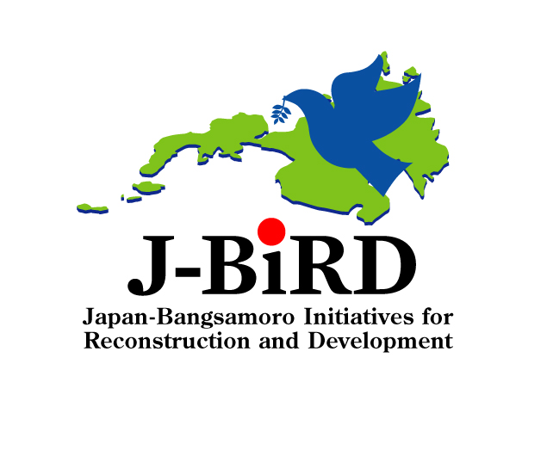
March 22, 2010
The Embassy of Japan in the Philippines
1. What is J-BIRD?
Launched in December 2006, J-BIRD (Japan-Bangsamoro Initiatives for Reconstruction and Development) is designed to contribute to the peace process and development in the Conflict-Affected Areas in Mindanao (CAAM) and the surrounding areas in the ARMM (Autonomous Region in Muslim Mindanao). The objective of J-BIRD is to enable the people and the communities in the target areas to enjoy the “dividends of peace” through the Japanese ODA on the basis of “Human Security” principles. As of now, the total amount of the assistance is approximately \11.23B (PHP5.92B).

2. Grant Aid
- Grant Assistance for Grassroots Human Security Projects (GGP)
- Since the launch of J-BIRD in 2006, Japan has implemented 40 projects in conflict-affected areas in Mindanao, amounting to a total of approximately \313M (PHP160.73M). 24 projects were implemented in the ARMM.
- The projects include construction or rehabilitation of schools, training centers, water supply systems and health centers, and provision of post-harvest facilities and equipment.
- Grant Aid for Japanese NGO's project: 1 project (construction of schools) in JFY 2009 (\13M: PHP6.68M)
- Emergency food aid of rice to Internally Displaced Persons (IDPs) through the United Nation’s World Food Programme (WFP): \860M (PHP441.61) (Distribution: Jan. 2009 – Jan. 2010)

3. Technical Cooperation
- Senior Advisor for Regional Development of ARMM: Japan dispatches a senior advisor who coordinates ODA projects for ARMM and provides policy advice on development issues with the ARMM government.
- ARMM Human Capacity Development Project (\350M: PHP179.73M): This project aims to improve capacity of middle management and operating core members of the ARMM government through the assistance for development of the Halal industry, establishment of the “ARMM Administration Code” and the “Human Resource Information System,” and management of infrastructure.
- Rice-based Farming System Training and Support for ARMM (\85M: PHP43.65M)
- Topographic Map for Peace and Development in Mindanao (\1.3B: PHP667.55M) (March 2010-): This project is going to update the topographic map of Mindanao, which will contribute to more effective formulation and smoother implementation of ODA projects.

4. Loan Aid
●ARMM Social Fund for Peace and Development Project
- This project started in April 2004, co-financed by Japan and World Bank. Japan’s contribution amounts to \2.47B (PHP1.27B).
- CDA (Community Development Assistance) projects (smaller infrastructure projects with 1.5M peso allotted for each barangay) and SRI (Strategic Regional Infrastructure) projects (larger infrastructure projects) are being conducted in the ARMM region.
- CDA and SRI projects include construction of multi-purpose centers, water-supply facilities / tanks, warehouses, schools, and roads.
- Central Mindanao Road Project (\3.7B: PHP1.90B): This project aims to construct roads between North Upi and Kalamansig (74.82km).

5. NPGA (Non-Project Grant Assistance) Counter Value Fund
- 3 projects were approved in June 2009:
- Construction of Japan-ARMM friendship hall and training center (\58M: PHP29.78M)
- Equipment supply for improvement of road network in ARMM (\282M: PHP144.81M)
- Personal computers for public high schools project (phase 4) (Mindanao) (\340M: PHP174.59M)

6. Others
- SERD-CAAM (Study for Socio-Economic Reconstruction and Development of Conflict-Affected Areas in Mindanao) (\684M: PHP357.23M) (March 2007- November 2009)
- This project created the “Socio-Economic Development Plan” (SEDP) for the reconstruction and development of conflict-affected areas based on the comprehensive social survey and need analysis conducted on 3,847 barangays.
- The study also implemented 11 QIPs (Quick Impact Projects) and 23 OSAs (On the Spot Assistance). These are small infrastructure projects (ex. schools, water supply facilities, rice mills) to address immediate needs of the barangays based on the “In-Depth Barangay Needs Analysis” (IBNA).
- Study on Infrastructure (Road Network) Development Plan for ARMM (\241M: PHP123.75M) (January 2008- March 2010)
*PHP-JPY Exchange Rate=0.5135 (2010 February Average)
(END)

